A Transformer-CNN Hybrid model for Segmenting Pavement Pothole

Tianjie Zhang1, Zhen Liu2, Xingyu Gu2 and Yang Lu3*

1 School of Computing, Boise State University, Boise, ID, 83725

2 School of Transportation, Southeast University, Nanjing, Jiangsu Province, China, 211189

3 Department of Civil Engineering, Boise State University, Boise, ID, 83725

***Abstract*:**

This work introduces a novel Transformer-CNN based model designed for the precise segmentation of pavement potholes. It has an encoder-decoder structure where Transformer is employed as the encoder and Convolutional Neural Networks (CNNs) are utilized as the decoder. Traditional techniques didn’t perform well due to the complex variations in pothole appearances and environmental conditions. The proposed model addresses these challenges by integrating the expansive representational capacity of Transformers with the precise local feature delineation capabilities of CNNs. Moreover, we collected and presented an open-source heterogeneous pothole dataset which can be used as a benchmark dataset for pothole segmentation research. We compared the performance of the proposed model with other state-of-the-art models, including U-Net, E-Net, LRASPP, FCN and AttuNet based on the proposed dataset. Results show that its performance surpasses other deep learning models with a mIoU of 77.23% and mPA of 84.48%.

***Key words:***  **Transformer, Pothole, Image Segmentation, CNN, Deep Learning.**

# 1. Introduction

Due to the climate changes such as heavy snow and rainstorms, there are increasing pavement defects like potholes all over the world [1]. Potholes not only pose safety hazards to road users but also contribute to accelerated pavement deterioration [2]. Accurately identifying and segmenting potholes from pavement images is crucial for effective road maintenance planning, targeted repairs, and resource allocation [3]. Pothole detection and maintenance are becoming of paramount importance in transportation infrastructure management [4]. There are a number of methods that can be used to inspect and detect potholes on road surfaces. These methods include visual inspection, automated inspection [5], ground penetrating radar [6], light detection and ranging (LiDAR) [7], and infrared thermography [8, 9]. By using these methods, pavement management agencies can identify and repair potholes before they become a hazard to drivers and cyclists. Traditionally, regular visual inspections are one of the most common methods for detecting potholes [10]. The pothole is visual inspected by professional engineers, but it is dangerous, labor-intensive, inefficient, and time-consuming [11]. Furthermore, the visual inspection for pothole detection is subjective and very dependent on the experience and knowledge of the engineers [12]. Therefore, automated methods including image processing techniques and machine learning-based methods are emerged to solve this problem [13]. For example, Buza et al. [14] presented an unsupervised vision-based method by using image processing and spectral clustering to identify and estimate the location of potholes, but this method was only tested on 50 images and gained an accuracy of 81%. Koch et al. [15] proposed a novel method based on a histogram shape-based thresholding and morphological thinning and elliptic to automatically segment the potholes from pavement. However, methods based on conventional image processing and machine learning techniques often struggle to handle the challenges due to complex variations in pothole shape, texture, and lighting conditions.

In recent years, deep learning models have emerged as a superior alternative, offering significant advantages over traditional image processing approaches. Deep learning, powered by artificial neural networks with multiple layers, has revolutionized various fields, including transportation infrastructure detection [16-18]. The ability of deep learning models to automatically learn and extract meaningful features from data enables them to surpass the limitations of handcrafted features used in traditional methods [19]. Deep learning approaches, such as convolutional neural networks (CNNs), have demonstrated superior performance in a wide range of computer vision tasks, including object detection, defect classification, and semantic segmentation [20]. For example, Zhang et al. [21] proposed an ECSNet in segmenting the pavement distress in a real-time task. Ukawah et al. [22] used YOLOv3 SPP to detect the asphalt pavement pothole in a self-collected dataset and the result showed a mean Pixel Accuracy (mPA) of 88.93%. Ahmed et al. [23] proposed a modified VGG-16 by removing some convolutional layers and changing different dilation rates as a backbone in a Faster RNN network. The results showed that the modified VGG-16 can get a higher precision of 81.4% than VGG-16. The YOLOV5 with ResNet as its backbone got the highest mPA of 64.12%. These deep learning models leverage the hierarchical nature of neural networks to capture both low-level local features and high-level contextual information, enabling them to discern subtle patterns and distinguish between different types of distresses. However, there are disadvantages using pure CNN models. The most common architecture in deep learning models is the encoder-decoder structure [24] which CNN usually relies on. Given that CNN has an architecture concentrating on localized features extraction, using CNN as encoder primarily focuses on local features and might miss out on the broader context, which is essential in differentiating potholes from other similar-looking features on a pavement. Moreover, CNNs can easily overfit to specific textural patterns that occur in the training data, leading to less robust performance on unseen types of pavement or potholes with varying appearances.

While deep learning models have yielded impressive results, recent advancements in the field of natural language processing have introduced a new paradigm: Transformers [25]. Transformers have revolutionized language modeling tasks by effectively capturing long-range dependencies and global context. This attention-based architecture has shown remarkable success in handling sequential data and has recently been extended to image analysis tasks. For example, Dosovitskiy et al. [24] proposed a Vision Transformer model (ViT) on image classification tasks and it was compared to state-of-the-art convolutional networks, including ResNet and EfficientNet. The results showed that the proposed ViT performed better on datasets like ImageNet [26], CIFAR [27] and Oxford-IIIT Pets [28]. Zheng et al. [29] proposed a sequence-to-sequence structure, SEgementation TRansformer (SETR), to treat the image segmentation tasks. The transformer layer was used to encode the images through a sequence of patches. This method reached a mean Intersection over Union (mIoU) of 82.15% in the Cityscape validation dataset [30]. These attempts showed that transformer layers are good at encoding the information from the images at a high level of accuracy and efficiency without losing broader context details. Transformers have also started been utilized and applied in the pavement crack detection. Han et al. [31] proposed Transformer FRTS to predict various asphalt pavement health indicators like rutting depth and surface texture depth. The inherent ability of transformer to model and extract complex relationships and capture fine-grained details makes them well-suited for analyzing spatial patterns in pavement images. However, transformer as decoders can be dependent on the specific application and the architecture of the network. In some cases, they might not be as effective as other approaches, such as CNNs, particularly when it comes to local feature extraction and pixel-level prediction tasks [32]. For example, Guo et al. [33] presented a Crack Transformer by integrating a swim transformer as its encoder and a Multi-Layer Perception (MLP) as its decoder to detect and segment the pavement cracks rather than using a pure Transformer model. Crack datasets including CFD [34] and Crack500 [35] were tested and it showed that the Crack Transformer can better retrieve the defect length. Given the weaknesses of CNN and Transformer, it is desirable to develop a new network model to form a stronger network that can avoid weakness and utilize the strength of both.

Thus, in this paper, we propose a novel approach, “PoFormer”, which is a Transformer-CNN hybrid model to leverage the power of transformers and CNNs in Pothole segmentation. In this model, the input images would be sequenced first to several patches and then a transformer-based encoder would be adopted to extract the pattern and information from the patches. And then, a decoder with 4 convolutional layers is utilized to take the encoded information and spatial features and reconstruct them into an output of the same size as the original image, but with segmented regions. By adapting this transformer-CNN-based architectures specifically for pothole detection, we aim to overcome the limitations of traditional CNN-only methods, like limited contextual understanding and overfitting on textural features, to further improve the accuracy and robustness of pothole segmentation. Moreover, the transformer’s ability in capturing long-range dependencies and contextual relationships in image and the convolutional layers in extracting spatial hierarchies are fully utilized in the model. Through extensive experimentation and comparisons with traditional deep learning models, we demonstrate the effectiveness of our proposed approach in accurately identifying and delineating potholes from heterogeneous pavement surface images.

In the Methodology Section, we introduce the PoFormer architecture, the overall evaluation procedure and the evaluation metrics we used in the work. Then, in the Results and Discussion Section, we present the statistics of the pothole dataset we collected and present the experimental results of testing models. At last, we discuss the implications of our findings and conclude with remarks on the potential and future directions of transformer-CNN hybrid approaches for pavement analysis.

# 2. Methodology

## 2.1. PoFormer

Transformer and CNN are two fundamental architectures in the field of deep learning. Transformer, known for its prowess in handling sequential data, primarily relies on a self-attention mechanism that allows it to weigh the importance of different parts of the input data. It can capture and utilize relationships between elements in a sequence that are separated by considerable distances. Given the complex pavement service status, pothole detection is not limited to recognizing the pothole itself but understanding its context within the surrounding pavement, which may include varying textures and conditions. This holistic view allows for more accurate and robust segmentation. CNN is well-established in image processing for its ability to extract spatial hierarchies of features due to the convolutional layers, which is crucial for accurately identifying and delineating the shapes and boundaries of potholes in varied pavement conditions. Combining the Transformer as the encoder and CNN as the decoder in one model, we anticipate taking the advantage of both. Thus, a Transformer-CNN hybrid model, PoFormer, is proposed in this work to segment the pothole from the pavement. The proposed PoFormer model is designed to enhance the performance of pavement pothole detection through enlarging the receptive fields of CNN-based part and compensating the Transformer part for the loss of local fine-grained contextual information. The neural network architecture of the proposed PoFormer model is shown in Figure 1.

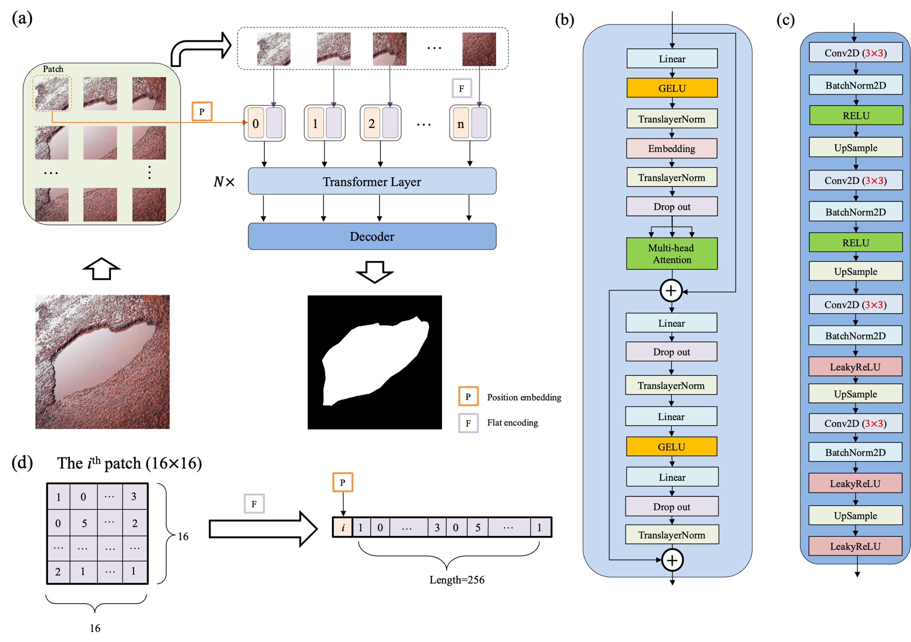

**Figure 1.** The structure of the proposed PoFormer and its components. (a) The overall workflow of the PoFormer model. (b) The Transformer Layer and utilizing it as the encoder in this model to extract the information from the images; (c) The structure of the Decoder, which is a CNN-based structure. (d) The flat encoding and position embedding process during image sequentialization; the number in the patch and sequence represents the pixel value.

As illustrated in Figure 1(a), the proposed PoFormer architecture is consisting of an image sequentialization part, an encoder and a decoder. The resolution of images in this dataset ranges from $200×133$ pixels to $4032×3024$ pixels as the images are collected from different resources. Hence, the input images would be resized to $256×256$ first before doing the image sequentialization as the model requires a fixed-size input which is crucial for batch processing. Moreover, resizing to $256×256$ helps to reduce the computational burden, making the training and inference processes more efficient. Because the transformer layer asks for sequence data as its input, the resized 2D images would be transferred to one-dimensional sequences to meet the requirement of the input to a transformer layer. The model intakes a pavement image and partitions it into *n* patches (in this case, each patch has a resolution of $16×16$, therefore, *n* equals to 256). As shown in Figure 1 (d), these patches undergo a linear transformation to obtain flat encodings (*F*) with an added positional embedding (*P)*, formalized as *P*(*i*)+*F*(*pi*), where *pi* is the *ith* patch and *P*(*i*) is its corresponding positional embedding. This positional information is vital in maintaining the geometric fidelity of the patches, which is paramount in accurately segmenting the intricate features of potholes.

In the encoder as shown in Figure 1(b), the patch embeddings are processed through *N* Transformer layers (*N*=12 in this case). Each layer is composed of a multi-head attention (*A)* and a position-wise feed forward network (*F)*, where residual connections and layer normalization (TranslayerNorm) are applied before each sub-layer. Multi-head attention [24] is utilized in the encoder to capture complex dependencies and handle sequential data. Note that the multi-head attention is an extension of attention mechanisms. It allows the Transformer to jointly attend to information from different representation sub-spaces at different positions. The multi-head attention can be defined as Eq. (1):

$A=Concat({head}_{1}…,{head}_{h})W^{o}$ (1)

${head}_{i}=Attention\left({QW}_{i}^{Q},{KW}_{i}^{K},{VW}_{i}^{V}\right)$ (2)

where each ${head}_{i}$ is computed enabling the model to discern diverse feature interdependencies within the pavement image (h is defined as 12 in this model). $W^{o}$ stands for the output weight matrix to produce the final output, which carries the contextually enriched information. *Q*, *K*, and *V* stand for Query, Key, and Value, respectively. Query represents the set of vectors that are used to query the data. Keys are paired with values and are used to retrieve them. The similarity of a query with the keys determines how much attention is given to the corresponding values. Values are the actual content that you want to retrieve. The matrices $W_{i}^{Q}$, $W_{i}^{K}$ and $W_{i}^{V}$ are learned weight matrices that transform the input representations into the respective queries, keys, and values for the *ith* attention head. Each head in multi-head attention has its own set of these weight matrices, allowing the model to attend to different parts of the input in different ways simultaneously. The $Attention\left({QW}_{i}^{Q},{KW}_{i}^{K},{VW}_{i}^{V}\right)$ can be calculated as Eq. (3):

$Attention\left(Q,K,V\right)=softmax(\frac{QK^{T}}{\sqrt{d_{k}}})V$ (3)

Where $d_{k}$ is the scaling factor, which is the dimensionality of the keys and queries, used to avoid overly large dot products. *T* means the transpose operation. The SoftMax function is applied to the result of the scaled dot-product, providing a probability distribution.

Queries, keys, and values in the attention mechanism are vectors that represent different aspects of each patch in the input image. In the context of pothole segmentation, queries could be understood as representations of what the model is looking for (e.g., edges, textures associated with potholes), keys as aspects of the current patch that could be relevant to the search, and values as the actual content of the patch. In our proposed PoFormer model, the attention mechanism allows the model to focus on specific parts of the pavement images that are more relevant for identifying potholes, giving it the capability to distinguish between potholes and other similar-looking features on the road by learning the most pertinent features to pay attention to for the task at hand.

Within the Transformer layers, the feed-forward network employs the Gaussian Error Linear Units (GELU) [36] as the activation function, facilitating the model's ability to represent complex mappings. The network is formalized as Eq. (4):

$F(x)=GELU(xW_{1}+b_{1})W_{2}+b_{2}$*(4)*

which introduces necessary non-linearity into the feature transformation process. *W* and *b* are the weights and bias of layers. GELU is utilized as the nonlinear activation function in the encoder part. The equation of GELU is shown in Eq. (5).

$GELU\left(x\right)=x×ϕ(x)$ (5)

Where $ϕ(x)$ is the cumulative distribution function for gaussian distribution.

The feed-forward network within the Transformer layers further processes these features, employing the GELU activation function to introduce non-linearity, enhancing the model's ability to represent complex functions. The inclusion of dropout and layer normalization at each step mitigates the risk of overfitting and ensures stable learning, both of which are vital for the model to generalize well across varied pavement conditions.

The decoder architecture is illustrated in Figure 1(c). During training, the distribution of inputs to each layer changes due to adjustments in the parameters of the preceding layer. This slows down the training process because each layer requires re-initialization of its parameters. To address this, we apply 2D batch normalization (BatchNorm2D) [37] after each convolutional layer in the decoder. The batch normalization operation is defined in Eq. (6).

$y=\frac{x-μ}{\sqrt{σ^{2}+ϵ}}×γ+β$ (6)

Where *x* is the input, y is the output, γ and β are learnable parameters, $μ$ and $σ^{2}$ are the mean and variance of *x,* and $ϵ$ is a small constant added for numerical stability (set to $e^{-5}$ here).

The decoder utilizes a succession of upsampling and convolutional operations to translate the high-level Transformer features into a segmented image. The upsampled feature map is convolved with learned filters $W_{conv}$, followed by batch normalization and activation functions, encapsulated as $ϕ(B(Conv(U*W_{conv}+b_{conv})))$. This sequence is iterated to refine the segmentation granularity progressively as shown in Eq. (7).

$s= ϕ(B(Conv(U*W_{conv}+b_{conv})))$ (7)

Where *s* represents the sequence in decoder, *U* stands for the upsampled feature map, *B* represents the Batch Normalization, *ϕ is the activation function, Conv* stands for the convolutional layer*, $W_{conv}$* and $b_{conv}$ are the weights and biases of each convolutional layer*.*

RELU and LeakyRELU are used as the activation function in the decoder part. The equations are shown below.

$ReLU\left(x\right)=\left\{\begin{aligned}x, x≥0 \\ 0, otherwise\end{aligned}\right.$ (8)

$LeakyReLU\left(x\right)=\left\{\begin{aligned}x, x≥0 \\ ax, otherwise\end{aligned}\right.$ (9)

Where *a* controls the angle of the negative slope, $a=e^{-2}$ in this case. The LeakyReLU activation function can improve model fitting with minimal added computational cost and risk of overfitting.

Incorporating these academic notations and formulations equipped the model description with the necessary rigor for pavement surface pothole inspection.

## 2.2 Overall Evaluation Procedure

In order to evaluate the performance of the proposed method, five well-established models were evaluated alongside our novel Transformer-CNN hybrid model. The models under scrutiny are as follows: U-Net [38], LRASPP [39], FCN [40], E-Net [41] and AttuNet [42]. These models were selected based on their prominence in the field and their varied architectural principles, which include:

(1) U-Net: A convolutional network renowned for its efficacy in biomedical image segmentation.

(2) LRASPP: An adaptation of the Lite Reduced Atrous Spatial Pyramid Pooling (R-ASPP) Network, employing a MobileNetV3-Large backbone, optimized for mobile devices.

(3) FCN: The Fully Convolutional Network, herein utilizing a ResNet-50 [43] backbone, known for its deep residual learning framework.

(4) E-Net: A network architecture designed for real-time semantic segmentation, as originally proposed by Adam et al. [41], using the default hyperparameter settings.

(5) AttuNet: Specifically designed for scenarios with limited training samples, this model emphasizes attention mechanisms to refine feature representations.

A self-collected dataset is proposed to evaluate the performance of these models. The dataset has been published on GitHub Repository (<https://github.com/tjboise/PoFormer>). In this dataset, a total of 1,183 images featuring road surface potholes have been compiled, some sourced from the internet and others collected by our team. Thus, it contains heterogeneous features which can evaluate the generalization of the model in complex situations. To ensure statistical robustness, the original dataset underwent a randomized tripartite split, forming the basis for three independent training and testing cycles. This methodology enabled the computation of average performance metrics and associated standard deviations which can show the robustness of the model performance. The dataset was partitioned into training and testing subsets in an 80:20 ratio. Given the heterogeneous image resolutions stemming from varied acquisition sources, a standardization procedure resized all images to 256×256 pixels prior to model training. Data augmentation techniques, including random resizing and horizontal flipping [44], were systematically applied to the training images and their corresponding ground truths. Such augmentation generated novel inputs for the neural networks, enhancing the model's performance by leveraging the increased quantity and diversity of the dataset. Subsequent to augmentation, the training images were converted to grayscale to streamline the learning process. The step-wise of the model performance evaluation procedure is shown in Figure 2.

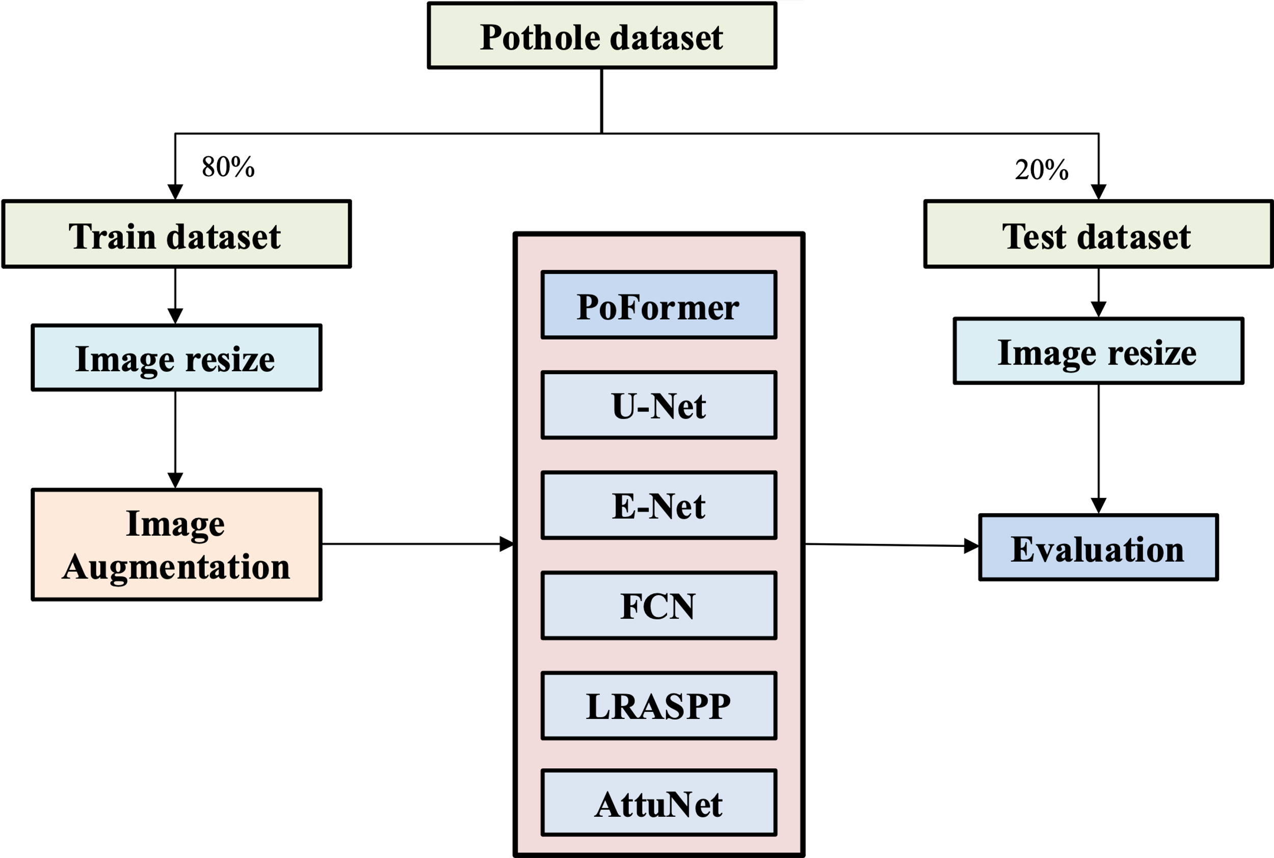

**Figure 2.** The overall procedure of model performance evaluation

Root Mean Squared Propagation (RMSProp) [45] was employed as the optimizer across all models to facilitate parameter updates. The ways to update the weights in the models are shown in Eq. (10) and (11).

$w\left(t+1\right)=w\left(t\right)-\frac{η}{\sqrt{v\left(t\right)+ϵ}}g\left(t\right)$ (10)

$v\left(t\right)=β∙v\left(t-1\right)+(1-β)∙{(g\left(t\right))}^{2}$ (11)

Where ***w***(*t*) is the model parameter at *tth* iteration, *v*(t) is the squared gradient moving average at time step, *g*(t) is the gradient, *η* is the learning rate. *β* is the decay rate (*β*=0.9). ϵ is a small scalar (e.g., 10-8) used to prevent division by zero.

RMSProp is an adaptive learning rate optimization algorithm which was designed to address the diminishing learning rates issue of Adaptive Gradient Algorithm. In RMSProp, the learning rate gets adjusted on a per-parameter basis, depending on the importance of the parameters. The training regimen consisted of 300 iterations for each network, with an initial learning rate set at 1e-3 and a batch size of 16. Classification thresholds were standardized; an output value exceeding 0.5 denoted a pothole, while values below indicated background. The loss function utilized was BCEWithLogitsLoss [46], which amalgamates a sigmoid activation with Binary Cross Entropy loss, offering enhanced numerical stability over the conventional approach of a standalone Sigmoid activation followed by BCELoss [42].

It is noteworthy that Transformer models are a type of neural network architecture that has been shown to be very effective for a variety of natural language processing (NLP) tasks, such as machine translation, text summarization, and question answering. However, transformer models can also be very computationally expensive to train and test. GPU (graphics processing unit) computing is a type of parallel processing that is well-suited for accelerating the training and testing of transformer models. GPUs are designed to perform large numbers of simple calculations simultaneously, which makes them ideal for the matrix operations that are used in transformer models. In this work, we used GPUs to significantly reduce the training and testing time of the transformer portion. We found that GPUs reduced the training time of a transformer model for machine translation by a factor of 10 than a CPU. In addition to accelerating the training and testing efficiency, GPUs can also be used to improve the accuracy of these models. By using GPUs, we can train transformer models on larger datasets and for longer periods of time, which can lead to improved performance on the PoFormer tasks. We implemented the PoFormer model and other CNN models in Python, and executed them on a system running Windows 10 with an Intel(R) Core(TM) i9-10900X CPU, an NVIDIA RTX A4000 GPU with 16GB of memory, and 64GB of system RAM.

## 2.3 Evaluation Metrics

We evaluate the performance of each model using Precision (P), Recall (R), F1 score, Mean Intersection over Union (mIoU), and Mean Pixel Accuracy (mPA). The F1 score is calculated as the harmonic mean of Precision (P) and Recall (R), according to Eq. (12).

$F_{1}=\frac{2PR}{P+R}$ (12)

Precision and recall are defined in Eq. (13) and (14).

$P=\frac{TP}{TP+FP}$ (13)

$R=\frac{TP}{TP+FN}$ (14)

Where TP, FP, and FN represent the number of true positives, false positives, and false negatives, respectively.

To assess the performance of the segmentation models, we employed mIoU and mPA as the principal metrics. The IoU metric quantifies the percentage overlap between the model's predicted pothole segmentation and the ground truth. mIoU is less biased towards the size of the pothole. It treats large and small potholes more equally, which is important in a real-world scenario where potholes vary significantly in size. It is calculated for each class separately within segmentation tasks according to the following equation:

$IoU=\frac{A_{o}}{A_{u}}$ (15)

Where $A_{o}$ denotes the area of overlap between the predicted segmentation and the ground truth, $A_{u}$ stands for the combined area of the predicted and ground truth segmentations.

The mIoU represents the mean of IoU scores across all classes. It is determined by averaging the IoU for each class, as expressed in the Eq. (16):

$mIoU=\frac{1}{n}\sum_{i=1}^{n}{{IoU}_{i}}$ (16)

Here, *n* is the number of classes within the dataset, which in our case is two (pothole and non-pothole areas).

Pixel Accuracy (PA) is another straightforward metric, defined as the ratio of correctly classified pixels to the total pixel count. For an individual class, PA is given by:

$PA= \frac{P}{T}$ (17)

where *T* is the total pixel count that should be classified within that class, and *P* is the number of pixels accurately classified as belonging to that class.

mPA is the average of the PA values across all classes, calculated using the formula.

$mPA= \frac{1}{n}\sum_{i}^{n}{{PA}_{i}}$ (18)

While mIoU focuses on the overlap of the segmented area, mPA gives insight into the overall accuracy across all pixels. The utilization of mIoU and mPA offers a balanced evaluation of the models, considering both the precision of the segmentation and the accuracy of the pixel classification, thereby providing a comprehensive view of the model's segmentation performance.

# 3. Results and Discussion

## 3.1 Dataset Characteristics for Open-source Data Access

Prior studies have often developed bespoke methods tailored to small, proprietary datasets to validate their accuracy. This practice, however, significantly hampers the comparability of various approaches. Consequently, we have established a comprehensive open-source database to serve as an empirical foundation for advancing research in pothole detection and segmentation. The dataset comprises 1183 manually annotated RGB images of potholes, ensuring a high level of detail and accuracy in the annotations. Moreover, the images in the dataset contain heterogeneous features such as ambient light conditions, weather conditions, color mode, shooting orientation, etc., which will pose challenges to the models and can help to train a robust model not overfitting on some features. Some representative images and its corresponding segmentations are shown in Figure 3.

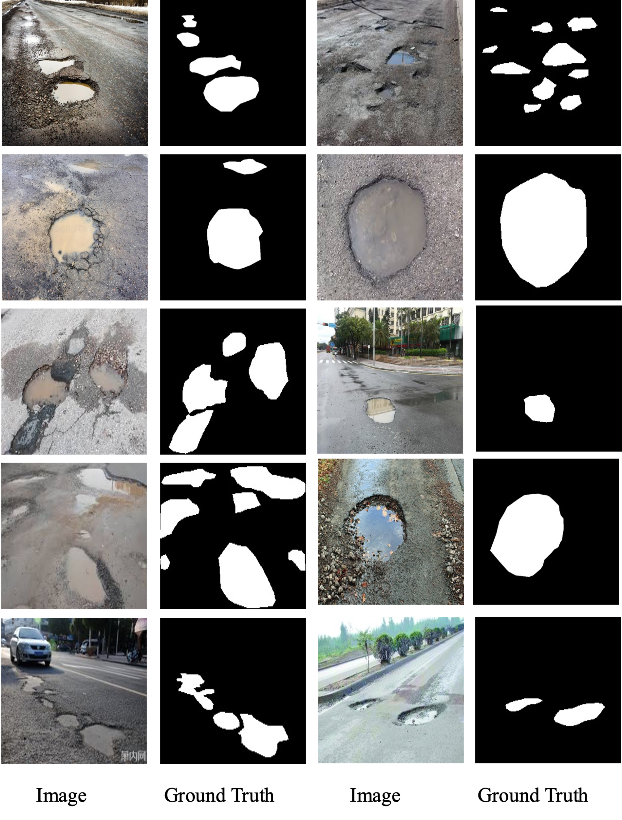

**Figure 3.** Some representative samples in the proposed dataset.

Figure 3 illustrates a curated selection of images from our comprehensive dataset, which is designed to reflect a range of real-world conditions affecting pothole visibility and detection. For example, the pothole is easily collecting water. The road condition could be complex, the vehicles, people, trees and building are all possible appeared in the background. That’s also the reason we collect heterogeneous features in the dataset. Accompanying each image is its respective binary segmentation mask, delineating the pothole boundaries for computer vision applications. This collection showcases various pothole scenarios, including different sizes, shapes, and severities, as well as a variety of environmental conditions such as wet and dry pavements. Most of the images contain more than one pothole and each one can be random size and irregular shape with wet or dry conditions, which demonstrate the strong heterogeneity features of pothole morphology distribution. The images originate from a dual-sourced methodology: the first set is derived from an extensive internet search to ensure diversity, and the second set consists of photographs taken manually by the research team, aiming to capture the nuanced details of potholes in local environments. This integrative approach can rise the difficulties when the model learns the features as different images have different resolutions and the pixels contained in pothole in different images may vary a lot. However, this kind of heterogeneous dataset can ensure the its robustness and its utility in developing and benchmarking pothole detection algorithms. Researchers and practitioners can access the full dataset, which contains heterogeneous images and precise annotations, on the GitHub repository at https://github.com/tjboise/PoFormer. The availability of this dataset aims to foster innovation and standardize benchmarks in the domain of automated pothole detection and segmentation as our intended contribution to the society of pavement defects segmentation and the data science community.

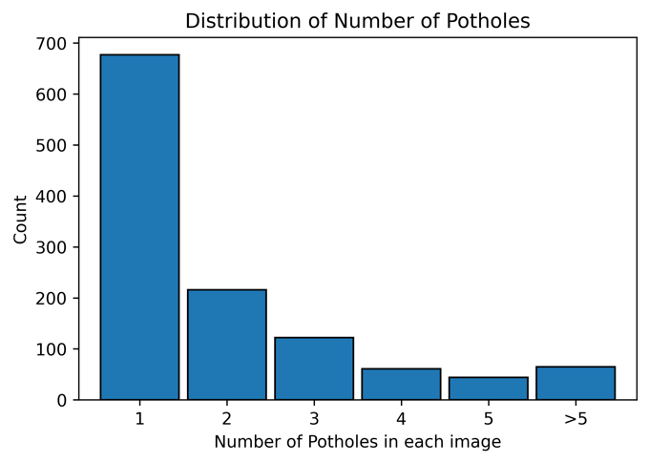

**Figure 4.** Distribution of Pothole Frequencies per Image in the Dataset.

Figure 4 provides a quantitative analysis of the pothole frequencies as observed in the dataset. It delineates the count of potholes per image, offering insights into the prevalence and clustering of potholes within individual images. Specifically, the dataset comprises 677 images each depicting a single pothole, highlighting the most common occurrence in urban settings. In contrast, a significant number of images, amounting to 506, feature more than two potholes. A smaller subset of 65 images captures scenarios with over five potholes, illustrating more severe roadway degradation. This variation in pothole distribution is reflective of actual road conditions and is critical for ensuring the diversity needed for training computer vision models. The wide range of pothole manifestations within the dataset is intended to bolster the generalization capabilities and enhance the robustness of pothole detection models when applied to real-world scenarios.

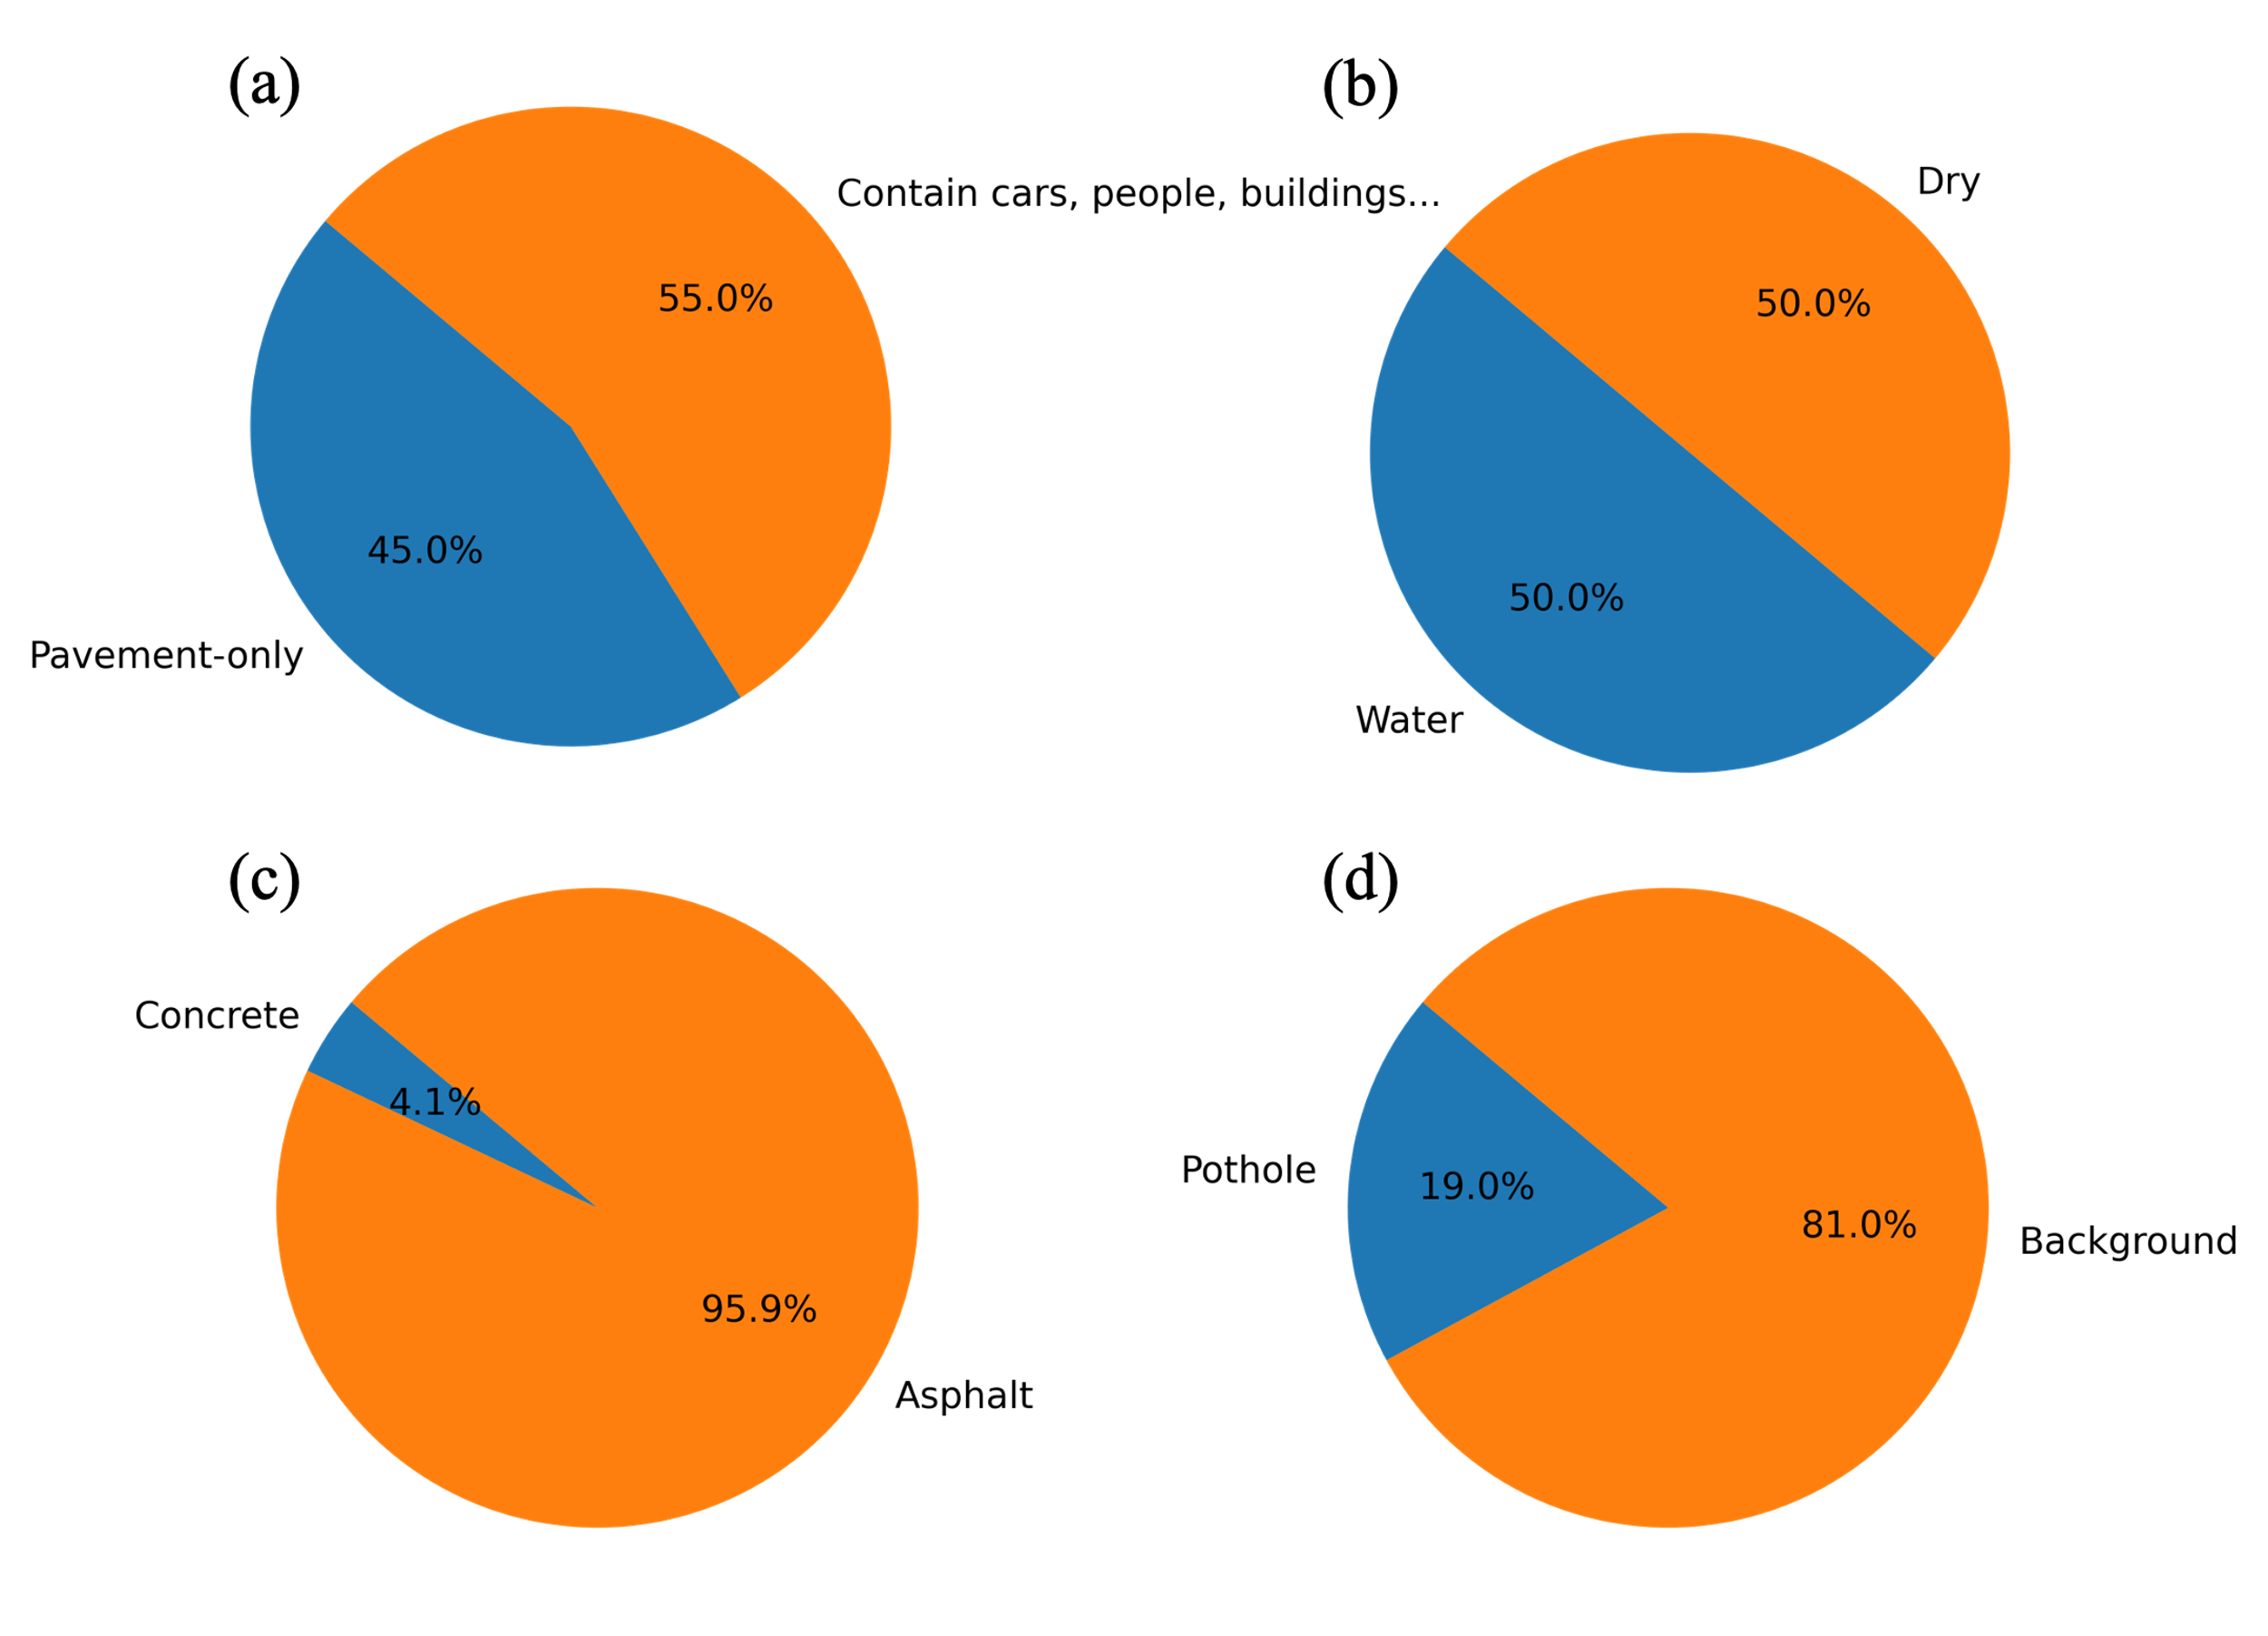

**Figure 5.** Compositional Statistics of the Pothole Detection Dataset.

Figure 5 provides a comprehensive breakdown of the dataset's composition in terms of various environmental and contextual factors relevant to pothole detection. Figure 5(a) contrasts the proportion of images featuring solely pavement backgrounds (45%) with those depicting additional elements such as vehicles, pedestrians, buildings, and vegetation (55%), underscoring the complexity the model must navigate. The presence of water in potholes, a factor influencing the performance of detection algorithms, is accounted for in Figure 5(b), which equally splits the dataset between wet (50%) and dry (50%) pavement conditions, thereby enhancing the robustness of the resulting model. Figure 5(c) differentiates between concrete (4.1%) and asphalt (95.9%) pavements, with the latter being more predominant, mirroring the common road compositions encountered in urban environments. Lastly, Figure 5(d) quantifies the pothole to non-pothole pixel ratio within the images, revealing that potholes account for an average of 19% of the image area, a statistic that further informs the severity of road damage represented in the dataset.

## 3.2 Model performance

Figure 6 presents the epoch-wise progression of the loss function for each evaluated model throughout the training phase. It is observed that PoFormer consistently maintains the lowest loss, indicative of superior model convergence and learning efficacy. In contrast, the FCN model exhibits the highest loss values across epochs, which correlates with its suboptimal performance on the test data. This inverse relationship between training loss and test performance suggests that PoFormer is better suited for capturing the nuances of the task, whereas the FCN model's learning trajectory indicates potential challenges in generalization or model capacity.

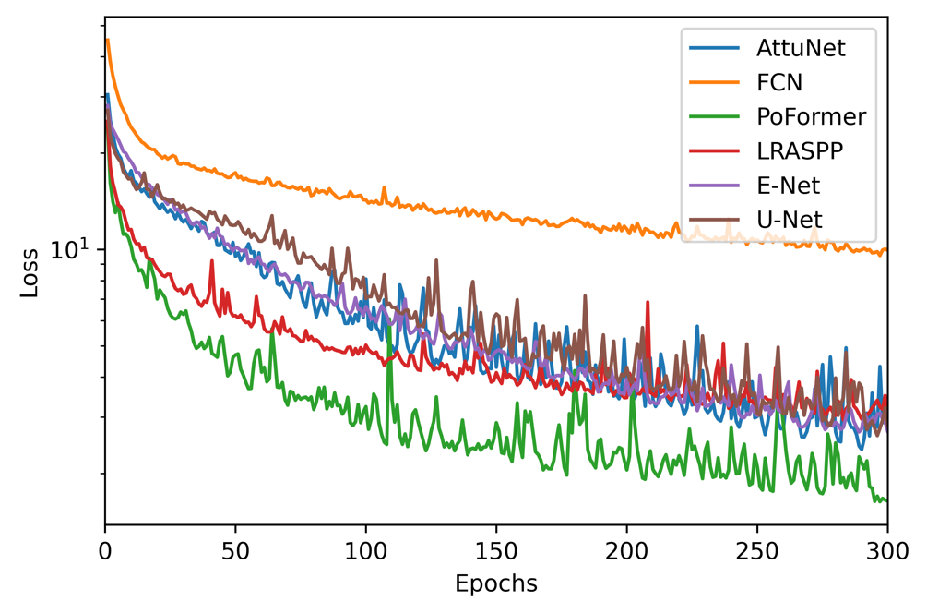

**Figure 6.** Epoch-wise Loss Trajectories for Evaluated Models.

Table 1 delineates a detailed comparative assessment of the evaluated models, including the proposed PoFormer, across key performance metrics including precision, recall and F1 score.

Table 1. Comparative Performance Metrics of Evaluated Models.

|  |  |  |  |
| --- | --- | --- | --- |
| Model | Precision | Recall | F1-score |
| FCN | 79.25 | 60.80 | 68.79 |
| E-Net | 83.77 | 66.87 | 74.31 |
| LRASPP | 86.08 | 71.31 | 78.0 |
| U-Net | **86.78** | 59.68 | 70.71 |
| AttuNet | 86.09 | 68.47 | 76.27 |
| PoFormer | 85.92 | **72.20** | **78.43** |

The data reveals that, while the U-Net model achieves the pinnacle of precision, it falls short in terms of recall, culminating in a diminished F1 score. Contrariwise, the PoFormer model excels, registering the most substantial recall and F1 scores among its counterparts. This suggests that PoFormer balances the trade-off between precision and recall more effectively, potentially rendering it a more robust solution for the given application.

Figure 7 presents the performance of various models evaluated in terms of mIoU and mPA. Each model was evaluated three times on distinct subsets randomly sampled from the full dataset. The mean and standard deviation of the performance metrics were then calculated across these three evaluation runs.

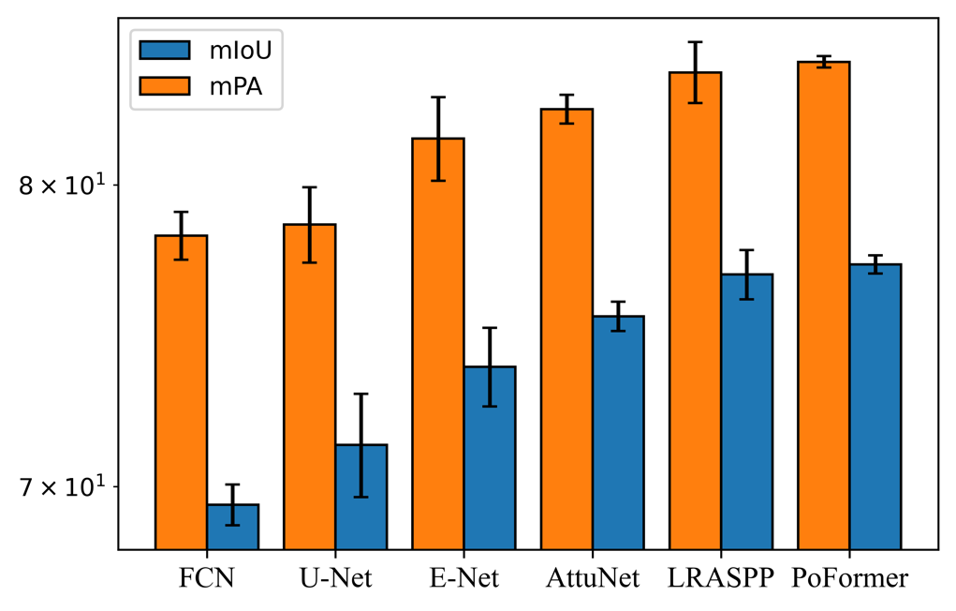

**Figure 7.** Comparative Analysis of mIoU and mPA Metrics Across Models.

The FCN registered an average mIoU of 69.44 (±0.63) and an average mPA of 78.23 (±0.83), reflecting consistent but the worst performance among all the models. The LRASPP model got the second place in both mIoU and mPA, achieving an mIoU of 76.89 and an mPA of 84.09. It performs a little lower than the proposed PoFormer. Our proposed method performed the highest accuracy among all the evaluated models, with an mIoU of 77.23 (±0.31) and an mPA of 84.48 (±0.22). The standard deviation is lower than other models. It means that PoFormer's performance is indicative of its both robustness and precision in segmenting potholes within the dataset.

To compare the final segmentation performance, Figure 8 visualizes example detection results for each of the deep learning-based models.

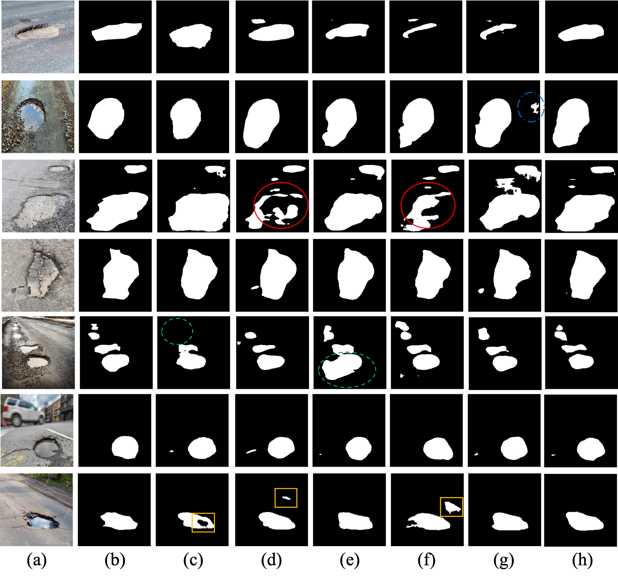

**Figure 8.** The visualization of detection results of compared methods: (a) Original Image; (b) Ground Truth; (c) E-Net; (d) FCN; (e) LRASPP; (f) U-Net; (g) AttuNet; (h) PoFormer.

As we can see from Figure 8, it is discernible that the FCN and U-Net models exhibit discontinuities in segmentation, particularly highlighted within the regions enclosed by red circles. These areas demonstrate a lack of alignment with the ground truth, with the models producing fragmented segmentations. The green-circled instances in the fifth row bring to light the limitations of E-Net, which omits smaller potholes. Although the F1 score of LRASPP is pretty close to the PoFormer, the recall value is 71.91 which is not as high as prediction results from PoFormer (72.20). That means the LRASPP tends to erroneously classify background pixels as potholes as we can see the green dash circle in the (e) column. The predicted pothole area in LRASPP is 58.7% larger than the ground truth while for the PoFormer, this value is just about 6.9%. The segments marked by yellow rectangular accentuate the propensity of both FCN and U-Net to engage in over-segmentation, misclassifying background areas as potholes, whereas E-Net tends towards under-segmentation, failing to encapsulate entire pothole regions. The visual comparison robustly illustrates the divergence in model performance, with PoFormer’s segmented outputs demonstrating remarkable concordance with the ground truth. This fidelity suggests that PoFormer outstrips the comparative models in discerning the nuanced features of potholes, thereby substantiating its superior segmentation capabilities.

# 4. Conclusion

In this work, a Transformer-CNN hybrid model, PoFormer, is proposed as an effective tool for segmentizing pavement potholes. It is an encoder-decoder structure where Transformer is used as the encoder and a CNN network is utilized as the decoder. It can leverage the strengths of both network architectures, utilizing Transformer to capture long-range dependencies and contextual relationships in data and applying CNN as the decoder to extract spatial hierarchies of features. The model demonstrates a strong capability to overcome the limitations of traditional CNN-only methods, like limited contextual understanding and overfitting on textural features, and significantly improved the accuracy and robustness of pothole segmentation enabled by transformer’s ability in capturing complex dependencies and handle sequential data. We compared the PoFormer with other art-in-state models including U-Net, E-Net, FCN, LRASPP and AttuNet. It shows that PoFormer achieves superior performance metrics, with a mIoU of 77.23% and a mPA of 84.48%. These results substantiate the model's capability to accurately segment potholes, which is essential for the development of intelligent transportation systems and infrastructure maintenance.

Besides, a heterogeneous dataset containing various resolution of pothole images are collected in this work and posted on the GitHub, which is designed to reflect a range of real-world conditions affecting pothole visibility and detection. This collection showcases various pothole scenarios, including different sizes, shapes, and severities, as well as a variety of environmental conditions such as wet and dry pavements. Most of the images contain more than one pothole and each one can be random size and irregular shape with wet or dry conditions, which demonstrate the strong heterogeneity features of pothole morphology distribution. This open-source pothole image dataset can be used as a benchmark dataset to evaluate the upcoming models designed for pothole segmentation tasks. This is intended to contribute to the society of pavement defects segmentation and data science community.

Future research directions include optimizing the model's computational efficiency and extending its application to other pavement distress types such as cracks. The findings of this study provide a foundation for the advancement of automated pavement condition assessment techniques, with the potential to significantly impact the field of transportation infrastructure management. The contributions of this research extend beyond pothole segmentation. The integration of transformers into pavement analysis tasks opens up new avenues for advanced computer vision techniques in transportation infrastructure management. The insights gained from this study can inform future developments in automated road condition assessment, maintenance planning, and resource optimization.

References

[1] T. Kim and S.-K. Ryu, "Review and analysis of pothole detection methods," *Journal of Emerging Trends in Computing and Information Sciences,* vol. 5, no. 8, pp. 603-608, 2014.

[2] A. Dhiman and R. Klette, "Pothole detection using computer vision and learning," *IEEE Transactions on Intelligent Transportation Systems,* vol. 21, no. 8, pp. 3536-3550, 2019.

[3] J. Guan, X. Yang, L. Ding, X. Cheng, V. C. Lee, and C. Jin, "Automated pixel-level pavement distress detection based on stereo vision and deep learning," *Automation in Construction,* vol. 129, p. 103788, 2021.

[4] N. Wang *et al.*, "3D reconstruction and segmentation system for pavement potholes based on improved structure-from-motion (SFM) and deep learning," *Construction and Building Materials,* vol. 398, p. 132499, 2023.

[5] S.-Y. Lee, T. H. M. Le, and Y.-M. Kim, "Prediction and detection of potholes in urban roads: Machine learning and deep learning based image segmentation approaches," *Developments in the Built Environment,* vol. 13, p. 100109, 2023.

[6] X. Xiong, Y. Tan, J. Hu, X. Hong, and J. Tang, "Evaluation of Asphalt Pavement Internal Distresses Using Three-Dimensional Ground-Penetrating Radar," *International Journal of Pavement Research and Technology,* pp. 1-12, 2024.

[7] R. Ravi, A. Habib, and D. Bullock, "Pothole mapping and patching quantity estimates using lidar-based mobile mapping systems," *Transportation Research Record,* vol. 2674, no. 9, pp. 124-134, 2020.

[8] Y. K. Cho, T. Bode, J. Song, and J.-H. Jeong, "Thermography-driven distress prediction from hot mix asphalt road paving construction," *Journal of construction engineering and management,* vol. 138, no. 2, pp. 206-214, 2012.

[9] T. Zhang, M. A. Rahman, A. Peterson, and Y. Lu, "Novel Damage Index-Based Rapid Evaluation of Civil Infrastructure Subsurface Defects Using Thermography Analytics," *Infrastructures,* vol. 7, no. 4, p. 55, 2022.

[10] A. Wang, H. Lang, Z. Chen, Y. Peng, S. Ding, and J. J. Lu, "The Two-Step Method of Pavement Pothole and Raveling Detection and Segmentation Based on Deep Learning," *IEEE Transactions on Intelligent Transportation Systems,* 2024.

[11] R. Fan, H. Wang, M. J. Bocus, and M. Liu, "We learn better road pothole detection: from attention aggregation to adversarial domain adaptation," in *Computer Vision–ECCV 2020 Workshops: Glasgow, UK, August 23–28, 2020, Proceedings, Part IV 16*, 2020: Springer, pp. 285-300.

[12] S. Mathavan, K. Kamal, and M. Rahman, "A review of three-dimensional imaging technologies for pavement distress detection and measurements," *IEEE Transactions on Intelligent Transportation Systems,* vol. 16, no. 5, pp. 2353-2362, 2015.

[13] K. Vigneshwar and B. H. Kumar, "Detection and counting of pothole using image processing techniques," in *2016 IEEE International Conference on Computational Intelligence and Computing Research (ICCIC)*, 2016: IEEE, pp. 1-4.

[14] E. Buza, S. Omanovic, and A. Huseinovic, "Pothole detection with image processing and spectral clustering," in *Proceedings of the 2nd International Conference on Information Technology and Computer Networks*, 2013, vol. 810, p. 4853.

[15] C. Koch and I. Brilakis, "Pothole detection in asphalt pavement images," *Advanced engineering informatics,* vol. 25, no. 3, pp. 507-515, 2011.

[16] A. Behzadian *et al.*, "The 1st Data Science for Pavements Challenge," *arXiv preprint arXiv:2206.04874,* 2022.

[17] T. Zhang, D. Wang, and Y. Lu, "RheologyNet: A physics-informed neural network solution to evaluate the thixotropic properties of cementitious materials," *Cement and Concrete Research,* vol. 168, p. 107157, 2023.

[18] T. Zhang, D. Wang, and Y. Lu, "Machine learning-enabled regional multi-hazards risk assessment considering social vulnerability," *Scientific Reports,* vol. 13, no. 1, p. 13405, 2023.

[19] S. Li *et al.*, "Detection of concealed cracks from ground penetrating radar images based on deep learning algorithm," *Construction and Building Materials,* vol. 273, p. 121949, 2021.

[20] T. Zhang, D. Wang, and Y. Lu, "Benchmark Study on a Novel Online Dataset for Standard Evaluation of Deep Learning-based Pavement Cracks Classification Models," *KSCE Journal of Civil Engineering,* pp. 1-13, 2024.

[21] T. Zhang, D. Wang, and Y. Lu, "ECSNet: An Accelerated Real-Time Image Segmentation CNN Architecture for Pavement Crack Detection," *IEEE Transactions on Intelligent Transportation Systems,* 2023.

[22] E. N. Ukhwah, E. M. Yuniarno, and Y. K. Suprapto, "Asphalt pavement pothole detection using deep learning method based on YOLO neural network," in *2019 International Seminar on Intelligent Technology and Its Applications (ISITIA)*, 2019: IEEE, pp. 35-40.

[23] K. R. Ahmed, "Smart pothole detection using deep learning based on dilated convolution," *Sensors,* vol. 21, no. 24, p. 8406, 2021.

[24] A. Dosovitskiy *et al.*, "An image is worth 16x16 words: Transformers for image recognition at scale," *arXiv preprint arXiv:2010.11929,* 2020.

[25] A. Vaswani *et al.*, "Attention is all you need," *Advances in neural information processing systems,* vol. 30, 2017.

[26] J. Deng, W. Dong, R. Socher, L.-J. Li, K. Li, and L. Fei-Fei, "Imagenet: A large-scale hierarchical image database," in *2009 IEEE conference on computer vision and pattern recognition*, 2009: Ieee, pp. 248-255.

[27] A. Krizhevsky and G. Hinton, "Learning multiple layers of features from tiny images," 2009.

[28] O. M. Parkhi, A. Vedaldi, A. Zisserman, and C. Jawahar, "Cats and dogs," in *2012 IEEE conference on computer vision and pattern recognition*, 2012: IEEE, pp. 3498-3505.

[29] S. Zheng *et al.*, "Rethinking semantic segmentation from a sequence-to-sequence perspective with transformers," in *Proceedings of the IEEE/CVF conference on computer vision and pattern recognition*, 2021, pp. 6881-6890.

[30] M. Cordts *et al.*, "The cityscapes dataset for semantic urban scene understanding," in *Proceedings of the IEEE conference on computer vision and pattern recognition*, 2016, pp. 3213-3223.

[31] C. Han *et al.*, "Asphalt Pavement Health Prediction Based on Improved Transformer Network," *IEEE Transactions on Intelligent Transportation Systems,* vol. 24, no. 4, pp. 4482-4493, 2022.

[32] J. Xu, W. Shi, P. Gao, Z. Wang, and Q. Li, "UperFormer: A Multi-scale Transformer-based Decoder for Semantic Segmentation," *arXiv preprint arXiv:2211.13928,* 2022.

[33] F. Guo, Y. Qian, J. Liu, and H. Yu, "Pavement crack detection based on transformer network," *Automation in Construction,* vol. 145, p. 104646, 2023.

[34] Y. Shi, L. Cui, Z. Qi, F. Meng, and Z. Chen, "Automatic road crack detection using random structured forests," *IEEE Transactions on Intelligent Transportation Systems,* vol. 17, no. 12, pp. 3434-3445, 2016.

[35] F. Yang, L. Zhang, S. Yu, D. Prokhorov, X. Mei, and H. Ling, "Feature pyramid and hierarchical boosting network for pavement crack detection," *IEEE Transactions on Intelligent Transportation Systems,* vol. 21, no. 4, pp. 1525-1535, 2019.

[36] D. Hendrycks and K. Gimpel, "Gaussian error linear units (gelus)," *arXiv preprint arXiv:1606.08415,* 2016.

[37] S. Ioffe and C. Szegedy, "Batch normalization: Accelerating deep network training by reducing internal covariate shift," in *International conference on machine learning*, 2015: pmlr, pp. 448-456.

[38] O. Ronneberger, P. Fischer, and T. Brox, "U-net: Convolutional networks for biomedical image segmentation," in *International Conference on Medical image computing and computer-assisted intervention*, 2015: Springer, pp. 234-241.

[39] A. Howard *et al.*, "Searching for mobilenetv3," in *Proceedings of the IEEE/CVF international conference on computer vision*, 2019, pp. 1314-1324.

[40] J. Long, E. Shelhamer, and T. Darrell, "Fully convolutional networks for semantic segmentation," in *Proceedings of the IEEE conference on computer vision and pattern recognition*, 2015, pp. 3431-3440.

[41] A. Paszke, A. Chaurasia, S. Kim, and E. Culurciello, "Enet: A deep neural network architecture for real-time semantic segmentation," *arXiv preprint arXiv:1606.02147,* 2016.

[42] T. Zhang, D. Wang, A. Mullins, and Y. Lu, "Integrated APC-GAN and AttuNet Framework for Automated Pavement Crack Pixel-Level Segmentation: A New Solution to Small Training Datasets," *IEEE Transactions on Intelligent Transportation Systems,* 2023.

[43] K. He, X. Zhang, S. Ren, and J. Sun, "Deep residual learning for image recognition," in *Proceedings of the IEEE conference on computer vision and pattern recognition*, 2016, pp. 770-778.

[44] Z. Liu, W. Wu, X. Gu, S. Li, L. Wang, and T. Zhang, "Application of combining YOLO models and 3D GPR images in road detection and maintenance," *Remote Sensing,* vol. 13, no. 6, p. 1081, 2021.

[45] T. Kurbiel and S. Khaleghian, "Training of deep neural networks based on distance measures using RMSProp," *arXiv preprint arXiv:1708.01911,* 2017.

[46] E. Salcedo, M. Jaber, and J. R. Carrión, "A Novel Road Maintenance Prioritisation System Based on Computer Vision and Crowdsourced Reporting," *Journal of Sensor and Actuator Networks,* vol. 11, no. 1, p. 15, 2022.